FITULATOR

Project Report Fulfilled the Semester Course

**Web Technology (CSC 303)**

B.Sc. Computer Science



Submitted by:

N. Datha Sai - AP23111260024

V. Reshmi - AP23111260016

G. Hemanth Reddy - AP23111260043

Richard - AP23111260059

Contents

**Abstract:** 3

Introduction: 3

Objectives: 4

Problem Statement: 4

Methodology: 5

Requirement Analysis 5

System Design 5

Dataset Creation 6

Implementation 6

Testing 7

Results: 12

Observations: 12

Final Output: 13

Conclusion: 19

## **Abstract:**

Fitulator is a goal-oriented fitness application designed to provide users with personalized exercise routines and diet plans to support weight loss, weight gain, and body maintenance. The app simplifies the process of choosing appropriate workouts and nutritional habits by categorizing fitness goals and offering structured guidance tailored to each user’s needs. Fitulator includes curated exercises, balanced meal plans, and an integrated timer to help users perform workouts accurately and consistently.

The goal-based layout and user-friendly interface ensure accessibility even for beginners, making fitness planning simple and effective. By combining exercise and diet recommendations in one platform, Fitulator promotes a healthier lifestyle and helps users stay motivated throughout their fitness journey. The project demonstrates the importance of personalized guidance in improving fitness outcomes and highlights Fitulator’s potential to evolve into a comprehensive digital fitness companion.

## 

## Introduction:

In today’s world, maintaining a healthy lifestyle has become increasingly challenging due to busy schedules and lack of personalized fitness guidance. Many individuals struggle with choosing the right exercises and diet plans suitable for their fitness goals such as weight loss, weight gain, or body maintenance. To address this problem, Fitulator has been developed as a simple, user-friendly fitness assistant application.

Fitulator provides goal-based workout routines, personalized diet suggestions, and easy-to-follow plans for users who want to improve their physical health. The application focuses on accessibility, clarity, and effectiveness, making it suitable for beginners as well as intermediate fitness enthusiasts.

## Objectives:

The primary objectives of Fitulator are:

To offer structured exercise routines for weight loss, weight gain, and maintenance.

To provide daily and weekly diet charts tailored to each fitness goal.

To ensure a clean and intuitive user experience suitable for all age groups.

To promote healthy lifestyles through balanced nutrition and consistent workouts.

To integrate timers, progress tracking, and motivational tips for better adherence.

## Problem Statement:

People often follow random online fitness routines without understanding their personal goals or body requirements. This leads to poor results, frustration, and loss of motivation. There is a need for a customizable and goal-oriented fitness system that gives proper exercise–diet balance in a simple format. Fitulator solves this by categorizing fitness goals and offering structured plans based on scientifically supported methods.

## Methodology:

The development of Fitulator followed a structured methodology involving:

### Requirement Analysis

Users should choose from three primary fitness goals:

Weight Loss, Weight Gain, Maintenance.

App must provide a combination of exercises + diet plans.

Include timers for workouts and rest periods.

### System Design

Homepage with 3 large sections/goals.

Exercise Page with:

Step-by-step workout guidance

Reps/sets information

Integrated timer

Diet Page with:

Meal recommendations

Vegetarian/non-vegetarian options

Calories breakdown

User-friendly UI with clear icons, large buttons, and intuitive navigation.

### Dataset Creation

Exercises and diet plans were curated based on:

Scientific fitness guidelines

Nutrition charts

Standard exercise difficulty progression

### Implementation

Frontend: HTML, CSS, JavaScript (or React if needed)

Components:

Goal selection module

Exercise recommendation logic

Diet recommendation module

Timer functionality

Backend (optional): Node/Express for storing plans or analytics.

### Testing

Checked app flow for errors

Usability tested on peers

Ensured all timers, pages, and responses work correctly

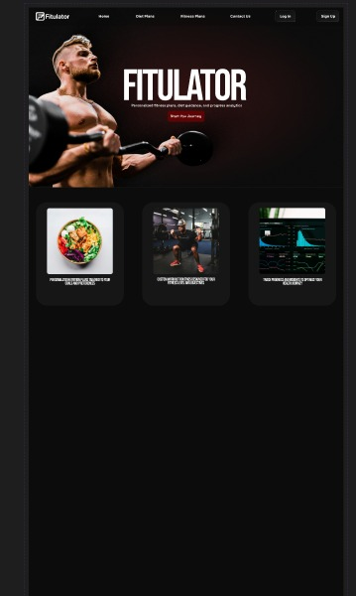

## Results:

Fitulator successfully provides users with clear, goal-based fitness guidance. Users found it easy to navigate and appreciated having diet and exercise plans categorized in one place. Testing showed that users could follow routines without confusion, and the structured format helped them stay consistent. The timers and categorized goals improved user engagement and made the experience more interactive. Fitulator demonstrated strong potential as an entry-level health and fitness companion app.

## Observations:

Users prefer simple, visually clear layouts for fitness instructions.

Goal-based categorization reduces confusion and increases motivation.

Diet + exercise combination leads to more effective results.

Timer functionality is essential for accurate workout execution.

Providing vegetarian and non-vegetarian diet options improves usefulness.

## Final Output:

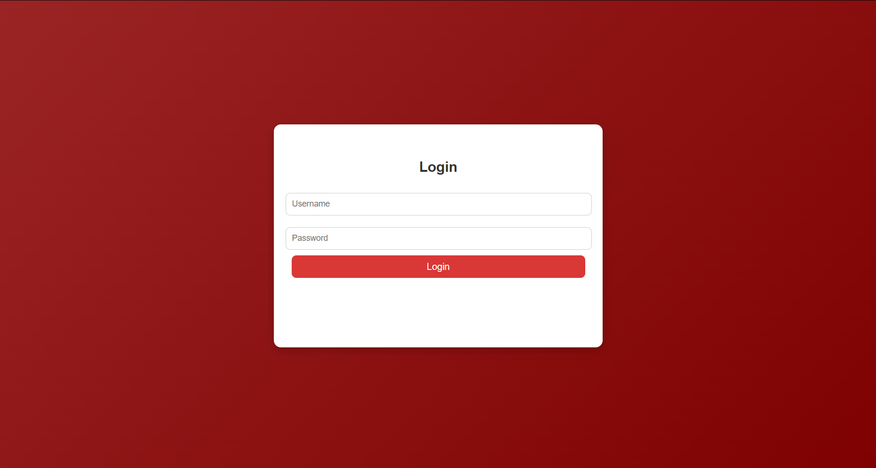

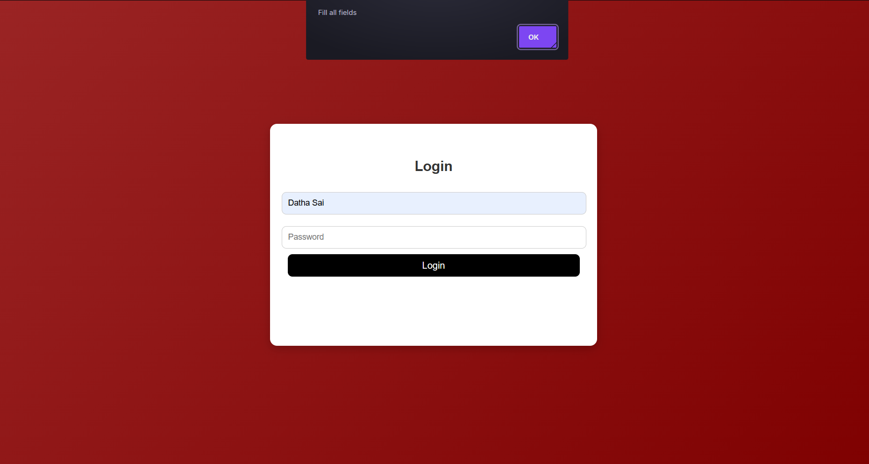

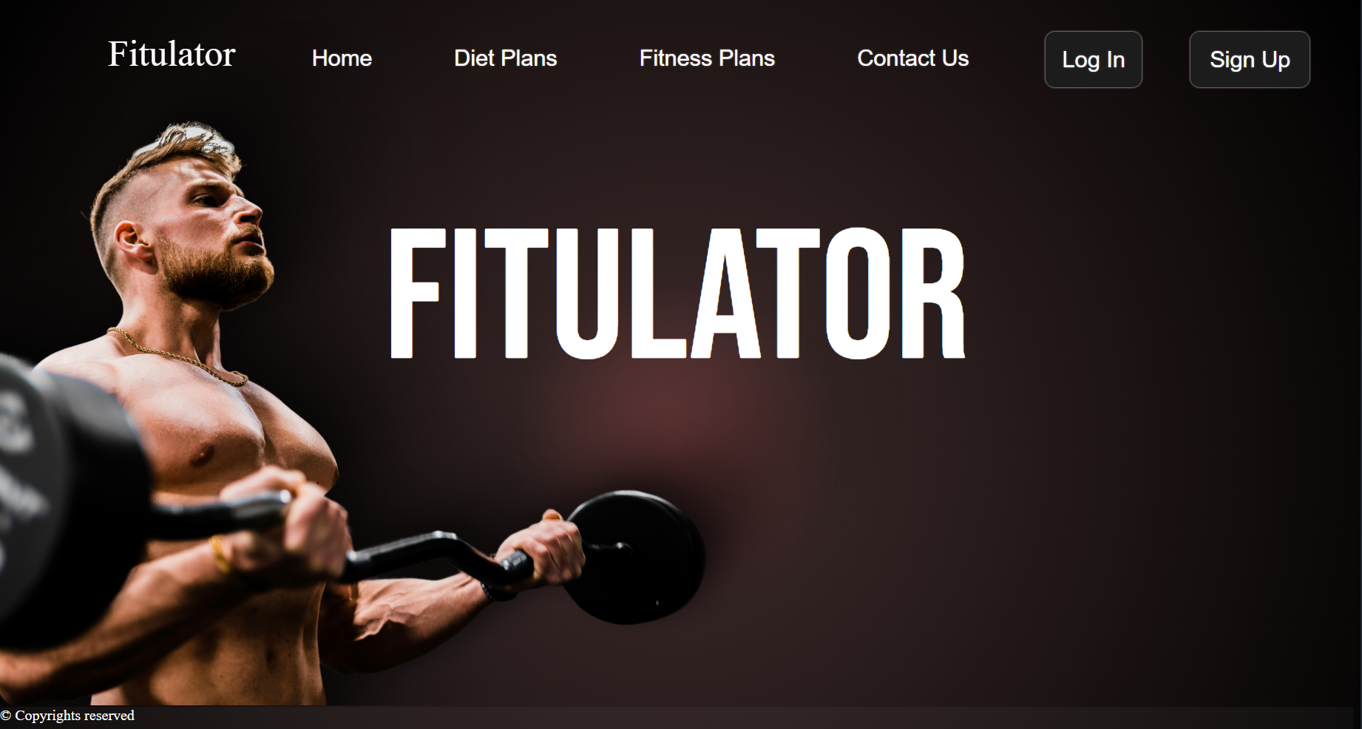

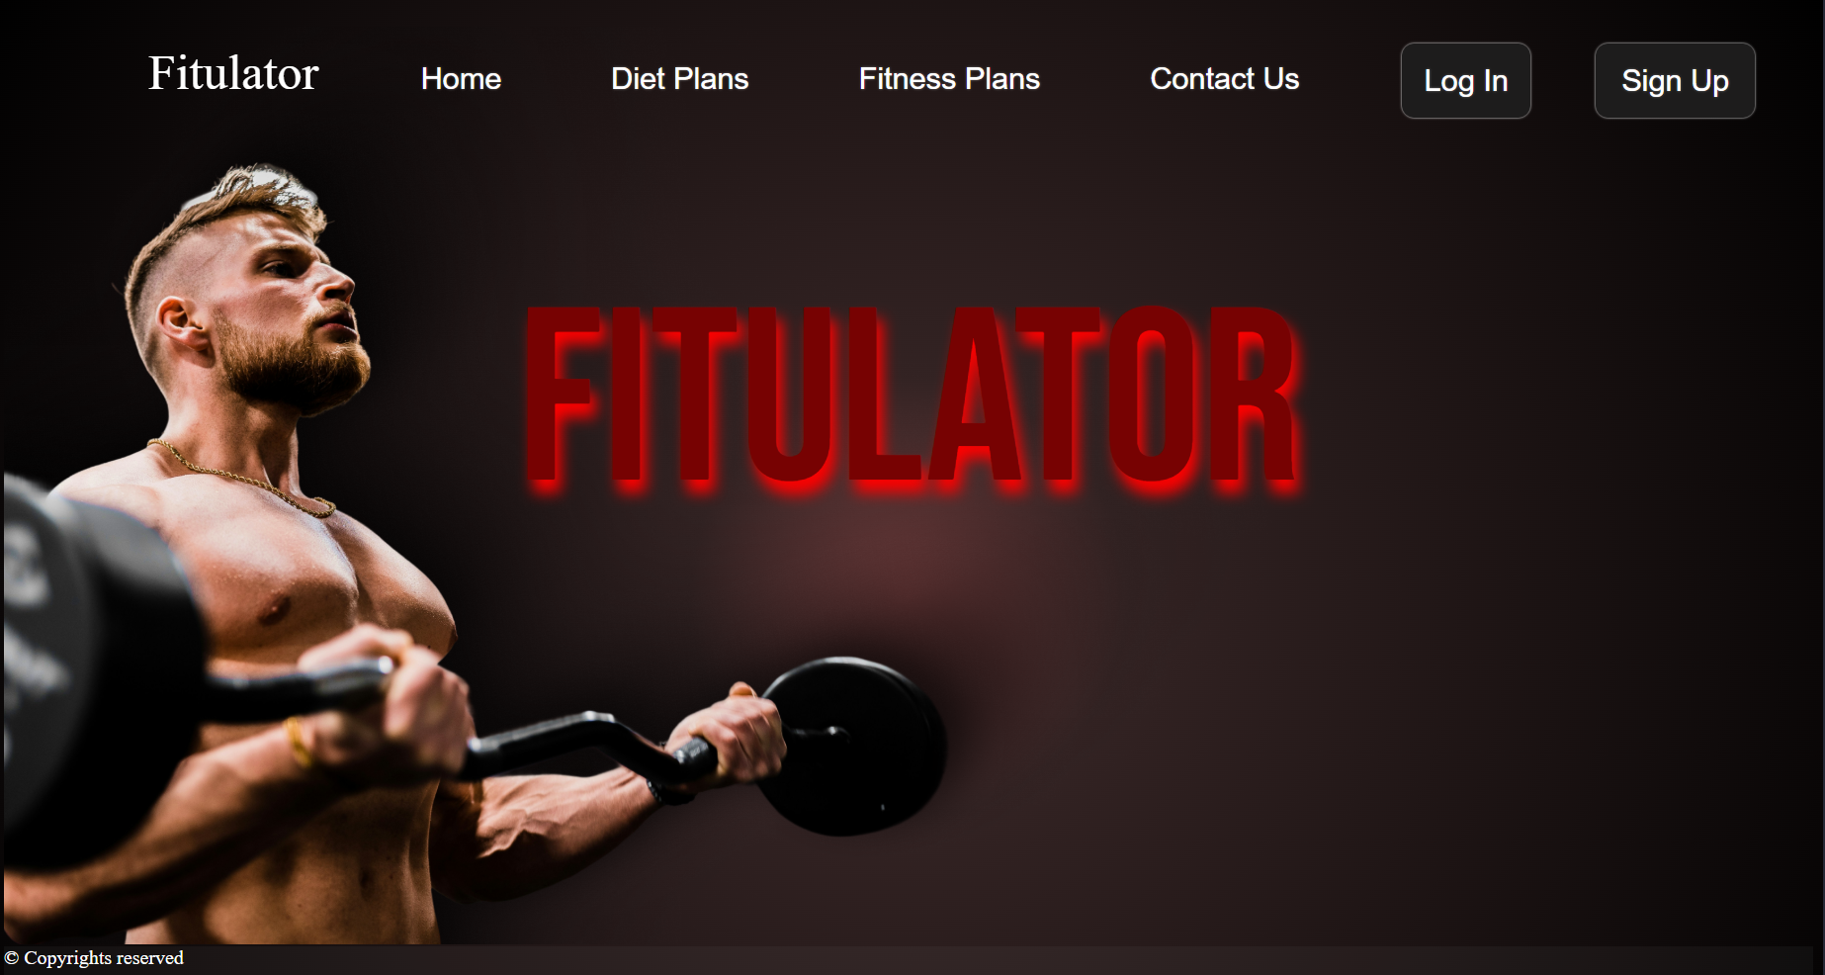

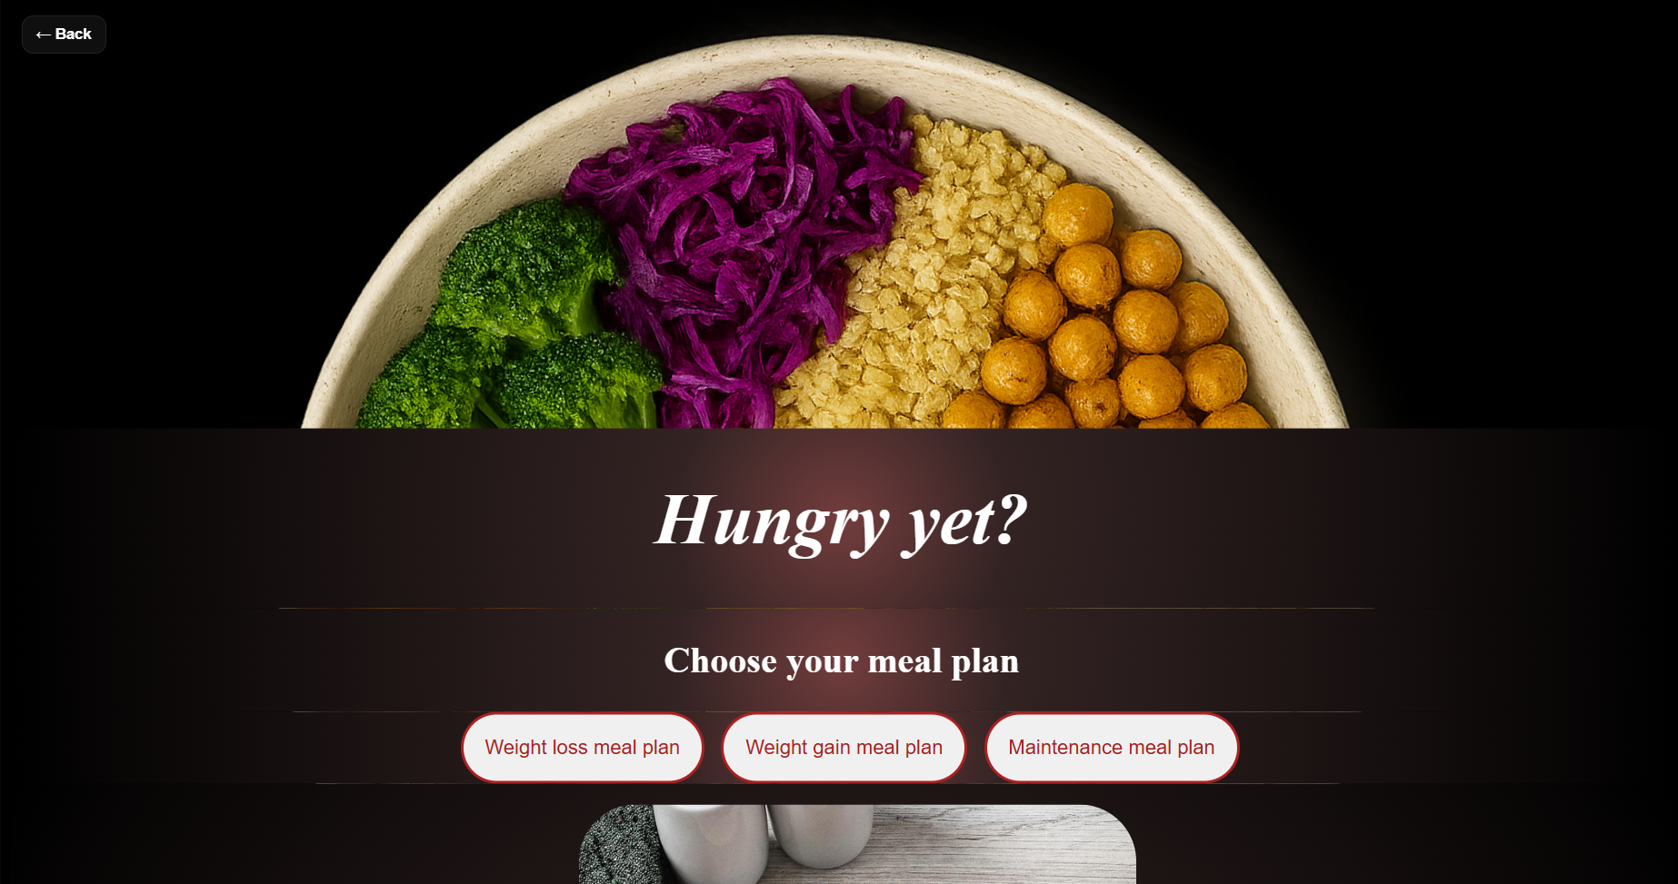



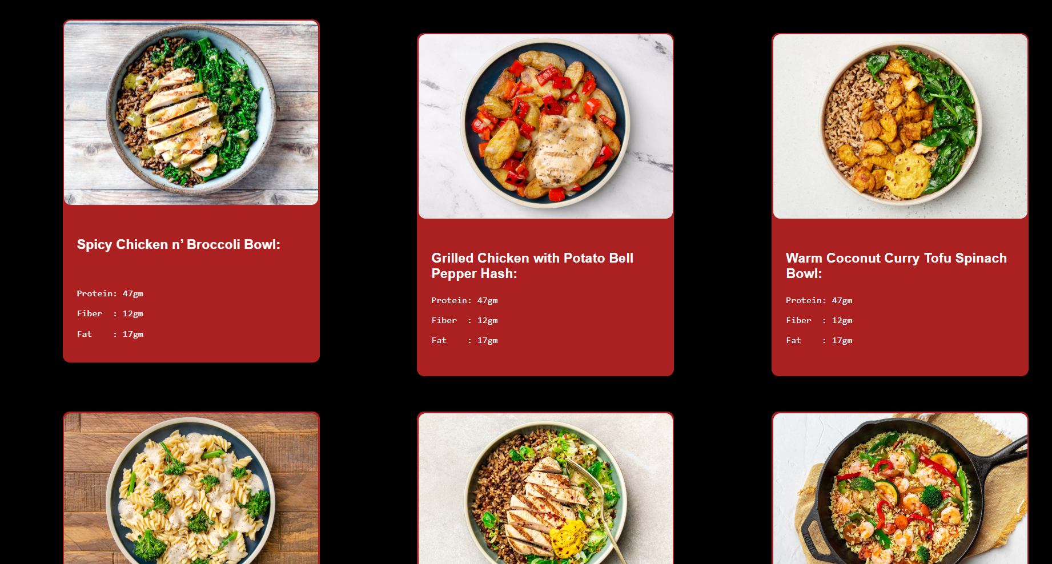

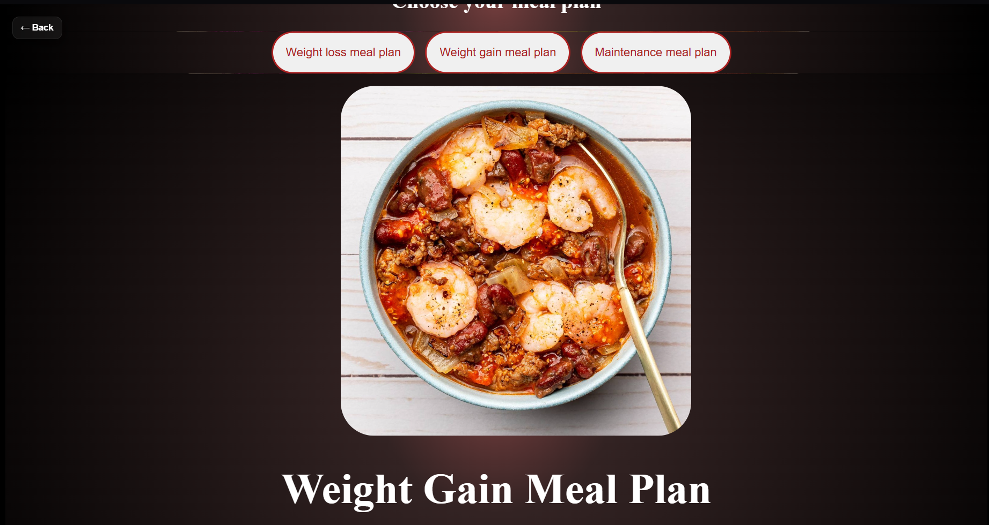

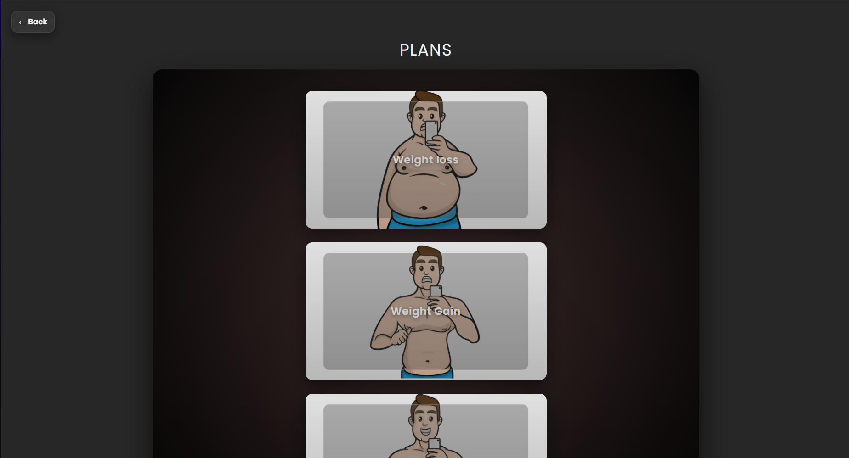

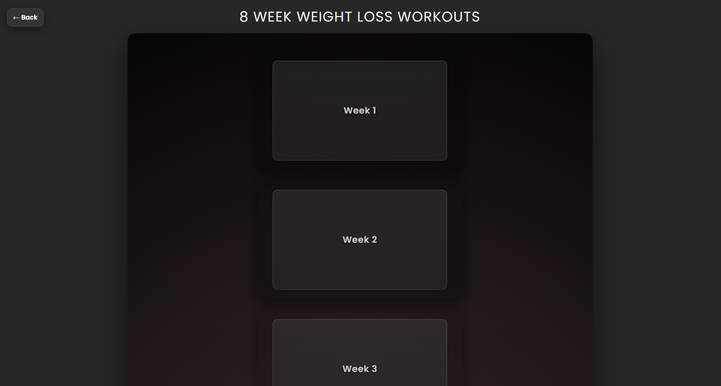

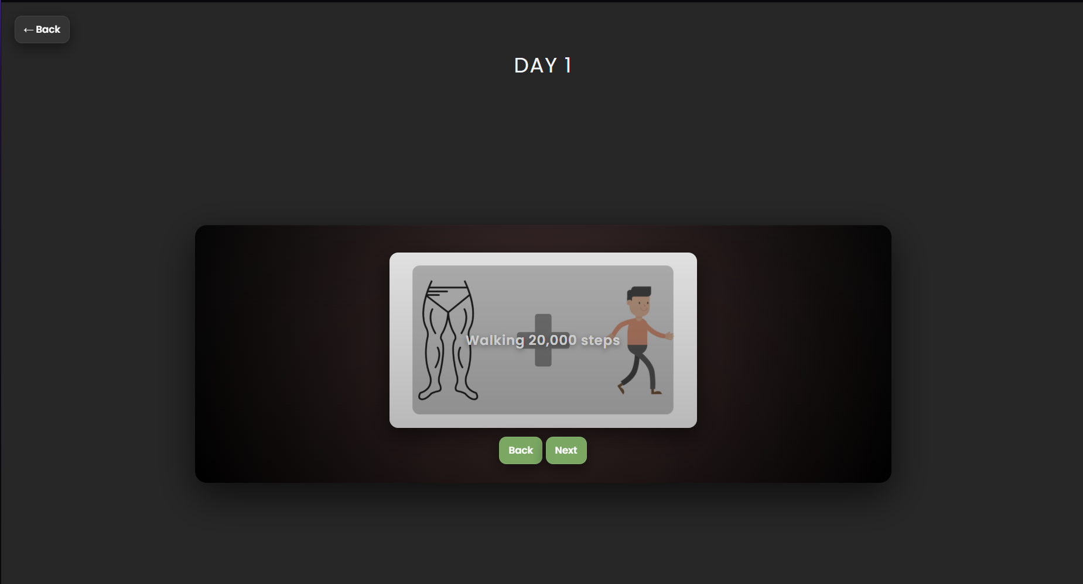

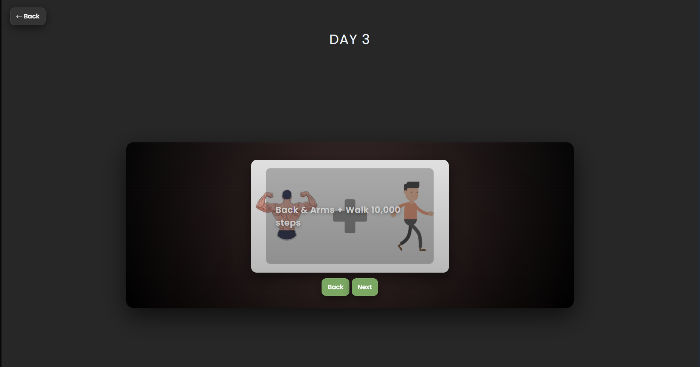

## Conclusion:

Fitulator is an effective fitness assistance application that provides users with structured exercise plans and diet charts based on their individual goals. By offering clear guidance for weight loss, weight gain, and maintenance, the app helps users stay consistent in their fitness journey. Its simple and user-focused design makes it a reliable tool for beginners. With further development—such as user accounts, calorie tracking, and progress analytics—Fitulator can be expanded into a full-scale fitness platform.